Name (first and last):

Ensemble:

Theory Diagnostic
Complete the following questions to the best of your ability. Save this as "[your name] theory diagnostic.pdf" and upload it to the appropriate assignment on google classroom. Please remember that this is only a diagnostic; whatever you know is great and whatever you don't know is ok too.

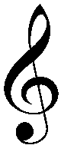
1. What are the two names for this clef?

2.What is the sentence for line notes in this clef?

3. There's a in the space (in ).

4. Write in all the letter names on each line and space in this clef.
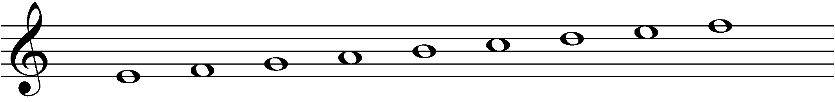

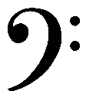
5. What are the two names for this clef?

6.What is the sentence for line notes in this clef?

7. What is the sentence for space notes in this clef?

8. Write in all the letter names on each line and space in this clef.

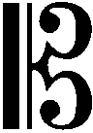
9. What are the two names for this clef?

10.What is the sentence for line notes in this clef?

11. Write in all the letter names on each line and space in this clef.

12. How many sharps are in the key of D major?
13. How many sharps are in the key of E minor?
14. How many flats are in the key of Db major? 15. How many flats are in the key of Bb minor?
16. What is the order of sharps in a key signature?
17. What is the order of flats in a key signature?

For questions 18-24, please use a lowercase b for flat and a pound sign (#) for sharp for any notes that need them.
18. What 3 notes are in a C major triad?
19. What 3 notes are in a C minor triad?
20. What 3 notes are in a B major triad?
21. What 3 notes are in a D diminished triad?
22. What 4 notes are in a CMA7 chord?
23. What 4 notes are in a Bb7 chord?
23. What 4 notes are in a Ami7 chord?
24. What 6 notes are in a D7#9+11 chord?

25. What is the pattern of whole steps and half steps for a major scale? Use W for whole and H for half.

Name the following intervals. Pay attention to the clef.
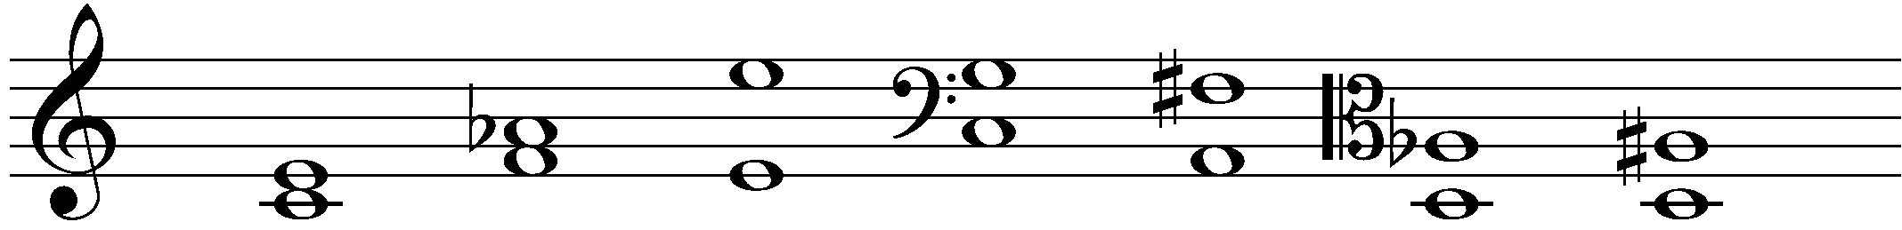
26. 27. 28. 29. 30. 31. 32.

Write in the counting on the following rhythms. Please write in counting to the eighth note on quarter and longer notes and rests. Please use + for "and". Use the counting system you've been taught for triplets and sixteenths. Please write in the counting on all notes AND rests.
33.

34.

35.
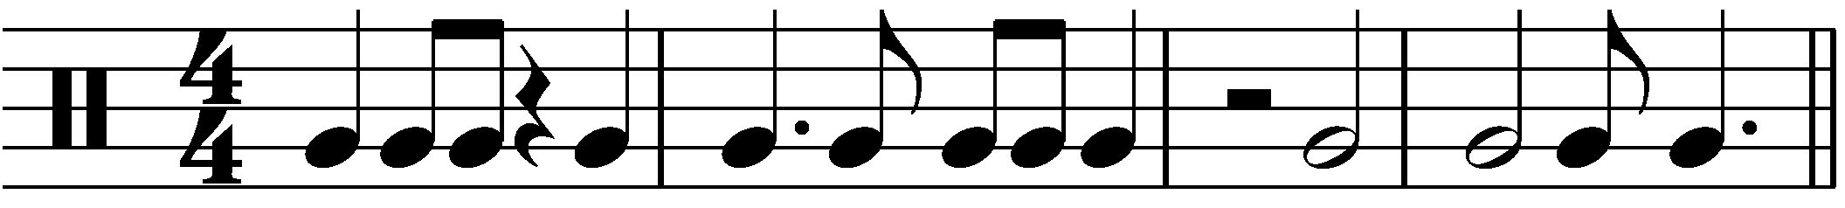

36.
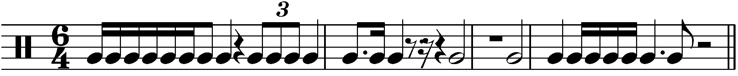

Write the correct name and meaning for each articulation.
37.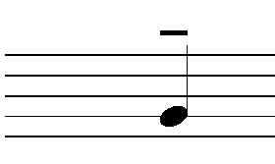  Articulation name  Meaning | 38.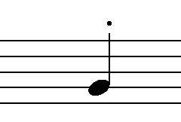  Articulation name  Meaning | 39.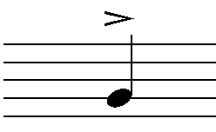  Articulation name  Meaning
40.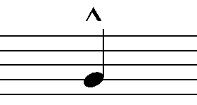  Articulation name  Meaning | 41.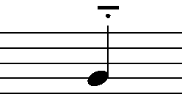  Articulation name  Meaning | 42.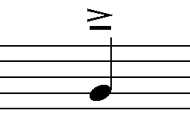  Articulation name  Meaning
43.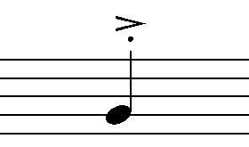  Articulation name  Meaning | 44.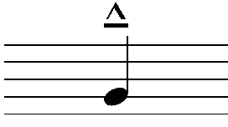  Articulation name  Meaning

45. Write the name and definition of each dynamic marking:
Symbol | Name | Definition
ppp
pp
p
mp
mf
f
ff
fff
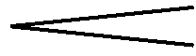
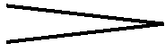

46. Write the definition (including approximate metronome markings, if you can) for each tempo marking:
Tempo marking | Definition
Largo
Moderato
Allegro
Vivace
Presto
Accel.
Ritardando

